1a)Study on Virtualization types and tools
AIM:
To study virtualization , its type and tools associate with the each virtualization.
Virtualization
Virtualization is the process of creating a virtual version of something, such as a server, a desktop, a storage device, an operating system, or network resources.
Types:
- Hardware Virtualization
  - Full virtualization
  - Para virtualization
  - Type 1 & Type 2 Hypervisors
- Operating System Virtualization
- Server Virtualization
- Storage Virtualization
- Network Virtualization
- Desktop Virtualization
- Application Virtualization
1)HARDWARE VIRTUALIZATION:
Allows multiple virtual machines (VMs) to run on a single physical machine using a hypervisor that abstracts the underlying hardware.
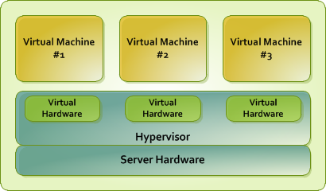
a). Full Virtualization
In full virtualization, the virtual machine completely isolates the guest OS from the virtualization layer and hardware. Microsoft and Parallels systems are examples of full virtualization.Tools Used:
- Oracle VirtualBox ,VMware Workstation/ESXi ,Microsoft Hyper-V ,KVM (when used with QEMU)
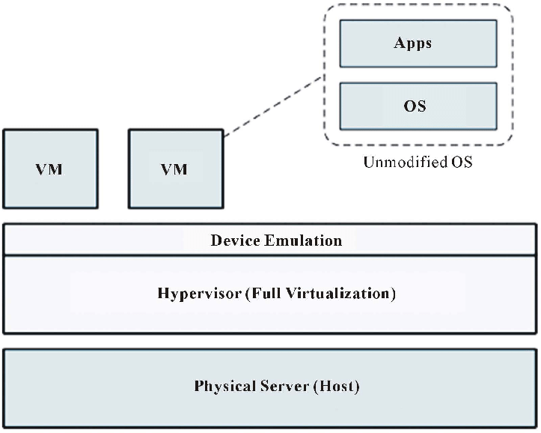
b. Para-Virtualization
Paravirtualization is the category of CPU virtualization which uses hypercalls for operations to handle instructions at compile time. In paravirtualization, guest OS is not completely isolated but it is partially isolated by the virtual machine from the virtualization layer and hardware.
Tools Used:
- Xen Hypervisor
- Older VMware versions with paravirt driversKVM (supports both modes)
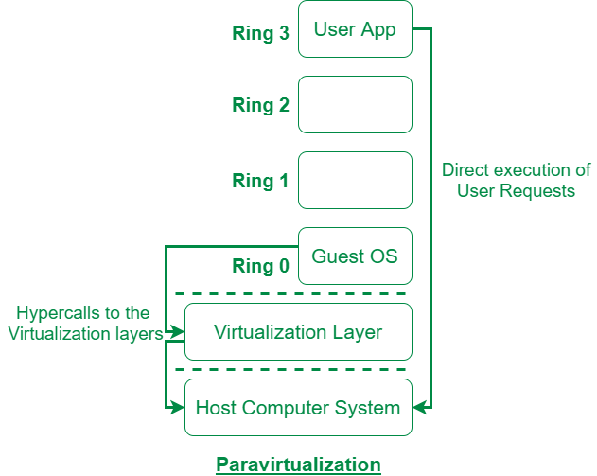
C. Type 1 & Type 2 Hypervisors
Type 1-Bare Metal Virtualization
This hypervisor runs directly on the host's hardware. It doesn't rely on a host operating system. This architecture offers better performance and security because there is no intermediary OS.
Tools:VMware ESXi, Microsoft Hyper-V (Server), Xen, KVM
Type 2-Hosted Virtualization
This type is generally used for desktop virtualization, development, and testing environments where a user needs to run multiple OSs on their personal computer. Performance is slightly lower than Type 1 due to the overhead of the host OS. Tools: VirtualBox, VMware Workstation, Parallels Desktop
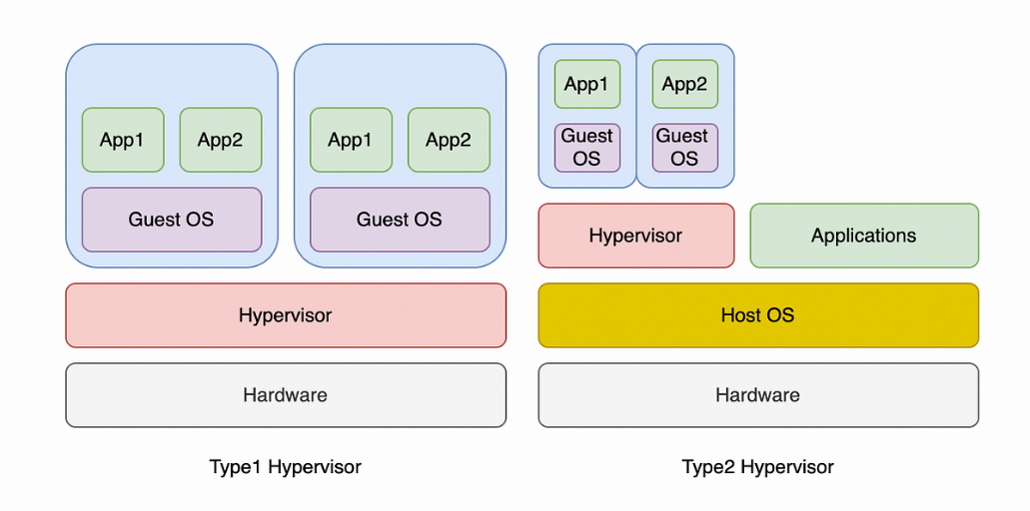
2)OS VIRTUALIZATION:
Uses a shared OS kernel to run isolated containers (user-space instances). Lightweight, fast, and great for microservices.
Tools:
- Docker ,LXC/LXD ,Podman ,Containerd
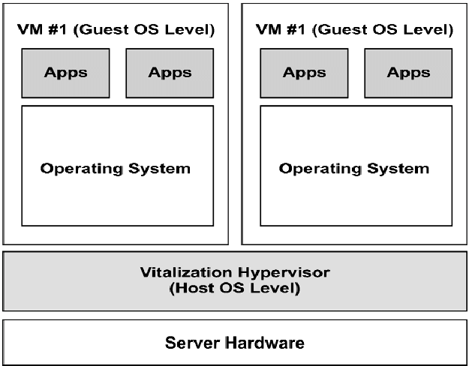
3) Server Virtualization
Divides a physical server into multiple virtual servers, each with its own OS and applications. It’s a major use case of hardware virtualization.
Tools Used:
- VMware ESXi
- Proxmox VE
- Microsoft Hyper-V
- XenServer
- KVM

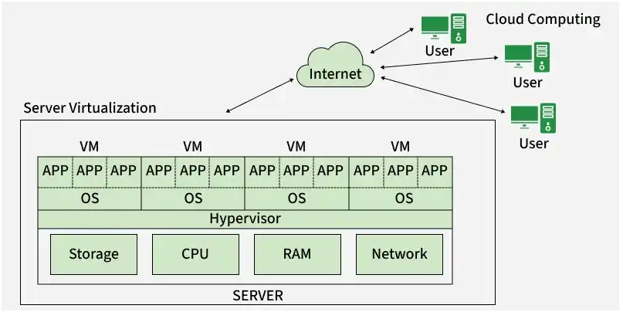
4) Storage Virtualization
Combines storage from multiple physical devices into a single virtual storage pool for easier management and scalability.
Tools Used:
- VMware vSAN
- IBM Spectrum Virtualize
- OpenFiler
- HPE 3PAR
- Ceph
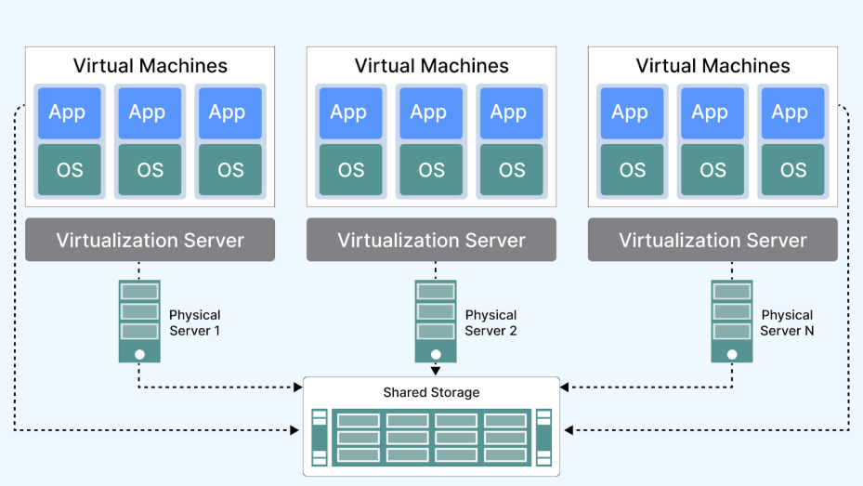
5) Network Virtualization
Abstracts physical networking devices into logical, software-defined networks. Allows virtual switches, routers, firewalls, etc.
Tools Used:
- VMware NSX
- Cisco ACI
- Open vSwitch
- GNS3 (for simulation/testing)
- Weave (for Docker networking)
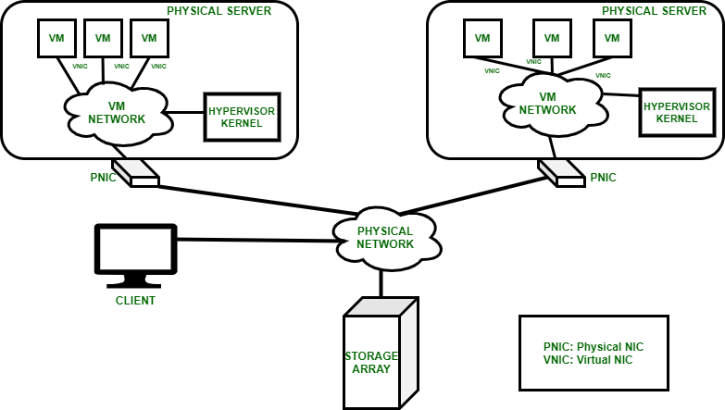
6) Desktop Virtualization
Hosts desktop environments on a central server, allowing remote access by users. Used in enterprises, labs, and remote work setups.
Tools Used:
- Citrix Virtual Apps & Desktops
- VMware Horizon
- Microsoft Remote Desktop Services (RDS)
- Parallels RAS
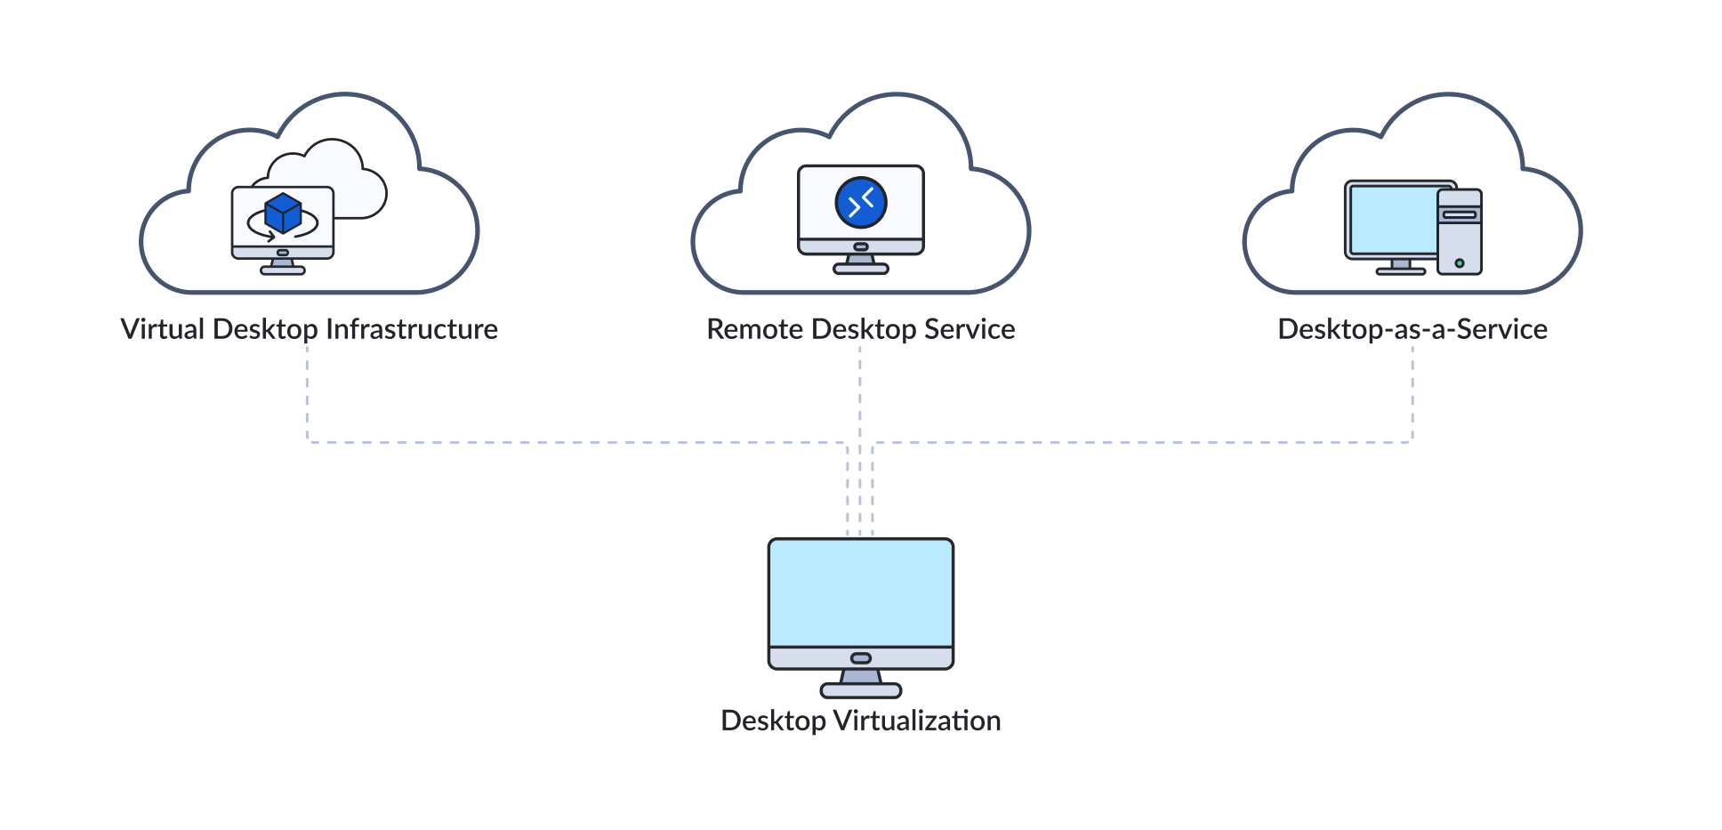
7) Application Virtualization
Runs applications in an isolated container so they don't need installation on the underlying OS — avoids conflicts and supports mobility.
Tools Used:
- Microsoft App-V
- Turbo.net
- Docker (for microservice-based apps)
- Cameyo
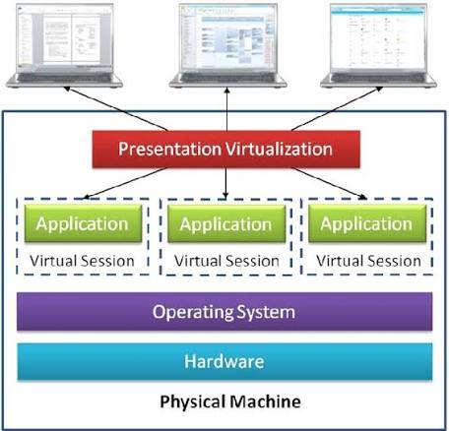

RESULT:
Thus the study of virtualization , its types and tools has been studied successfully .
1b)Review of Linux commands
AIM:
To study the linux commands and execute it using the virtualization tools (oracle virtual box)
Commands:
- Add a New User
Creates a new user account.
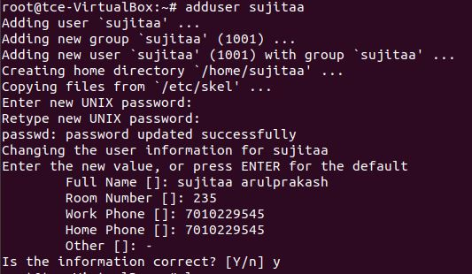
- Whoami
Displays the username of the current logged-in user.
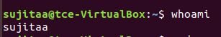
- pwd
Prints the current working directory path.
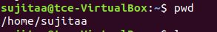

- ls
Lists files and directories in the current directory.
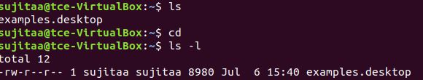
- ls -a
Lists all files and directories, including hidden file
- cd
Changes the current directory.

touch
Creates a new empty file.

- cat
Displays content of a file.Example: cat file.txt
- date
Displays the current date and time.
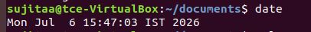

10. cal
Displays the calendar.
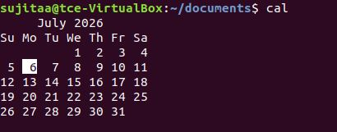
11.nano
Terminal-based text editors.Example: nano file.txt
12.Cp
Copies files or directories.Example: cp file1.txt file2.txt
13.mv
Moves or renames a file.
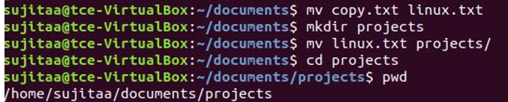
15)df
Shows disk usage and free space of file systems.Example: df -h (human-readable)
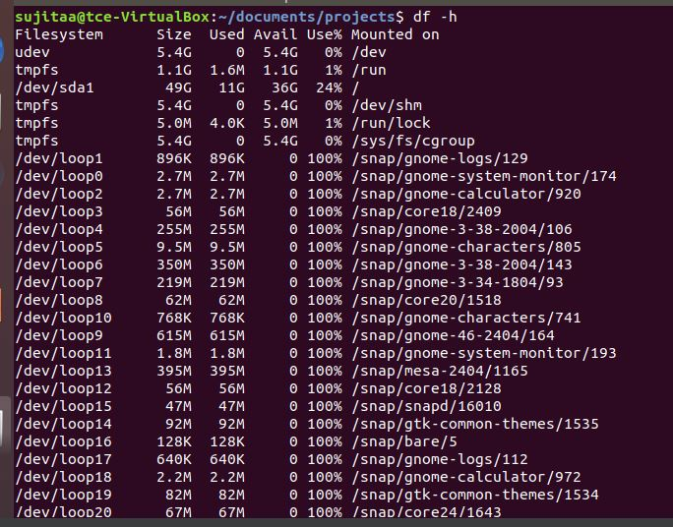
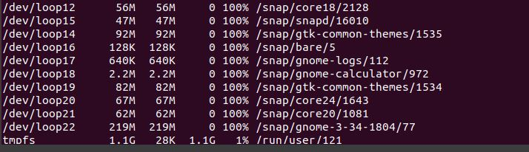
16. free-h
Displays system memory (RAM) and swap usage in a human-readable format.
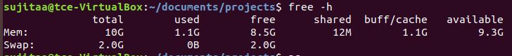
17. ps
Displays running processes.Example: ps aux
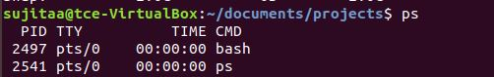
18.History
Displays a list of previously executed commands in the current shell.
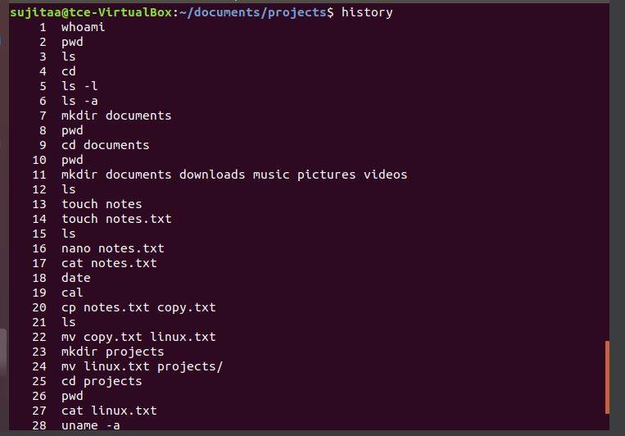
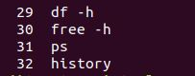
19.mkdir
Creates a new directory (folder).
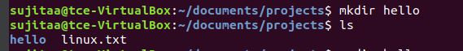

20. rmdir
Removes an empty directory.
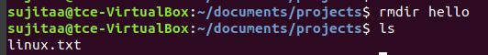
21.id
Displays user and group information for the current user or a specified user.
22.grep
Searches for patterns or keywords in files.Example: grep "error" logfile.txt
23.top
Displays system tasks and resource usage in real-time.Example: top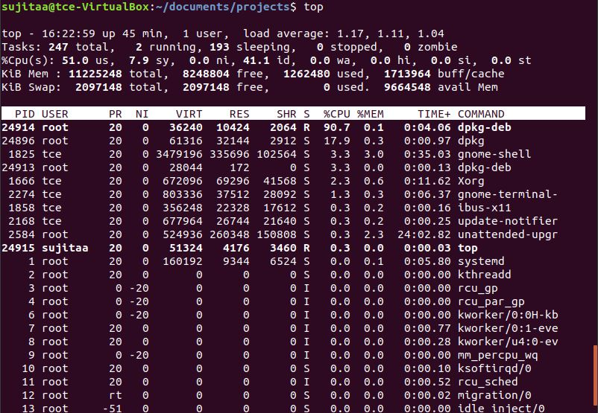
24.df
Shows disk usage and free space of file systems.Example: df -h (human-readable)
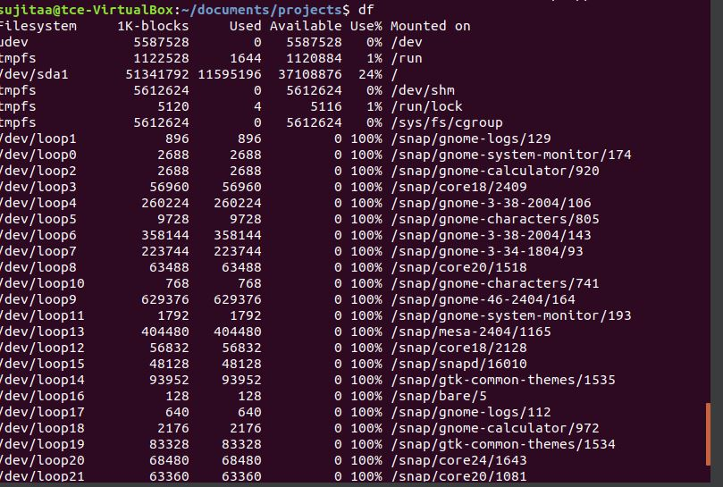
16. du
Shows disk usage of files and directories.Example: du -shfolder_name/
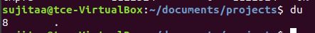

RESULT:
Thus the study of linux commands has been studied and executed successfully and output has been verified successfully

